SkillMatch AI

Software Engineering Document

Group 01 | Assignment 3 | Spring 2026

Table of Contents
1. Introduction
2. Requirements / System Modeling
3. Stakeholder Interviews
4. Agile User Stories
5. System Design
6. Architecture Design
7. Implementation
8. Software Testing
9. Software Evolution
10. Glossary

Introduction of Document – purpose of this document, audience, and structure
The purpose of this SED is to detail the high and low-level implementation details of the skillmatch AI automated resume system. The core idea of the product is a web-based AI-powered automation tool that lexically analyzes resume data and provides actionable insight.

This document is meant for everyone associated with the project, including developers, stakeholders, and testers. This document discusses core architectural, implementation, design, and testing decisions. All future changes should be reflected in this document and detailed accordingly.

Requirements / System Modeling

Functional requirements

Ali
- The system should parse resumes and extract them into structured data, including skills, experience, education, and certifications.
- The system will rank users on qualifications that match the posted job roles.
- The system will allow recruiters to filter candidates by fields such as skills, education, location, and years of experience
- The system will provide in-depth explanations for all its AI recommendations, showing how and why they were ranked the way they were.
- The system will allow recruiters to adjust or override AI rankings for candidates.
- The system will hide or remove demographic data as to reduce bias when doing resume screenings
- The system will secure data sent over the network and also that are stored for future use.
- The system will use role-based access control so that only users with proper permissions can access specific data.
- The system will be monitored through system logs to track performance, errors, and system activity
- The system will be scalable and built to handle high volumes of resumes, submissions, and tasks
Swara:
- Employees should be able to upload their resume in PDF or DOCX format.
- Employees should be able to drag and drop their resume into the upload area.
- After a resume is uploaded, the system should analyze the resume to identify the employee’s skills and qualifications.
- Employees should be able to select a target internal role from a list of available roles.
- The system should compare the employee’s skills with the requirements of the selected role.
- Employees should be able to view a skill match score showing how well their resume fits the selected role.
- Employees should be able to see which of their skills match the role requirements.
- Employees should be able to see which skills are missing for the selected role.
- The system should recommend learning resources or training options to help employees develop missing skills.
- Employees should be able to upload an updated resume.
Yash:
- The system should require Amazon single sign-on before any internal user can access the platform.
- The system should assign access permissions based on user roles such as employee, recruiter, hiring manager, Learning and Development lead, and system administrator.
- The system should keep an audit log of sensitive actions such as logins, failed login attempts, recommendation generation, recruiter overrides, report exports, and administrative updates.
- The system should allow system administrators to view system health information, sync status, and queue backlogs from connected services.
- The system should notify administrators when a connected service, import, or data-sync job fails.
- The system should retry safe background jobs after temporary service failures and prevent partial or inconsistent updates.
- The system should show employees which skills match a target role, which skills are missing, and how important each missing skill is.
- The system should generate prioritized learning recommendations that are directly tied to the employee’s missing skills and selected target role.
- The system should allow employees to save target roles, review previous analyses, and track progress after updating skills, training, or certifications.
- The system should provide Learning and Development teams with aggregated reporting on common skill gaps across departments, employee groups, and role families.

Non-functional requirements
Ali
- The system should parse resume data in less than 5 seconds.
- The system should handle 10,000 concurrent resume processes.
- The system should maintain 99.99% uptime.
- The system will encrypt all sensitive data using TLS, and when in storage, use industry-standard encryption.
- The system will include measures to keep services online through redundancy and failover.

Swara:
- The system should provide a simple interface for employees that is easy to use.
- The system should work on modern web browsers such as Chrome, Safari, and Edge.
- The system should keep logs of system activity and errors.
- The system should allow system updates without major interruptions to users.

Yash:
- The system should maintain high availability during normal business hours and peak hiring periods.
- The system should protect audit logs from tampering and store each event with a timestamp and authenticated user identity.
- The system should work reliably on approved modern desktop browsers used by internal users.
- The system should isolate failures in connected services so that one integration problem does not bring down the full platform.

Ali:

Role | Interview QS | AI response
Hr lead | How could the SkillMatch AI system improve recruiter efficiency when reviewing large volumes of resumes? | SkillMatch AI can improve recruiter efficiency by automatically parsing and structuring resume data, extracting key skills, experience, certifications, and education, and matching them against job requirements. The system should rank candidates based on job-relevant competencies while highlighting why a candidate was matched (e.g., specific skills or years of experience). Recruiters should be able to quickly filter candidates by criteria such as required qualifications, location, or experience level, reducing manual resume scanning. Additionally, features like duplicate detection, candidate clustering by skill sets, and automated shortlisting can significantly reduce review time while still allowing recruiters to focus on the most promising applicants.
Hr lead | What safeguards should SkillMatch implement to reduce bias when lexically analyzing resumes? | SkillMatch should implement several safeguards to reduce bias in lexical analysis. First, the system should exclude or mask demographic indicators such as names, gender-coded language, age indicators, or school prestige signals during the initial scoring process. Second, models should be regularly audited using fairness metrics to detect disparate impact across protected groups. Third, the training data used for the model should be diverse and carefully curated to prevent historical hiring bias from being reinforced. Finally, transparency should be built into the scoring system so recruiters can understand how rankings are generated and ensure that recommendations are based on job-relevant criteria rather than indirect demographic proxies
Hr lead | What tools should SkillMatch provide to allow recruiters to review or override AI recommendations? | SkillMatch should provide recruiters with clear decision-support tools rather than fully automated decisions. Recruiters should be able to view an explanation panel showing which skills, experiences, or keywords contributed to the AI’s ranking. The system should allow manual re-ranking, tagging, or promoting candidates that may have been undervalued by the model. Recruiters should also be able to adjust the weighting of job criteria (for example, prioritizing certifications over years of experience). An audit trail should record when and why AI recommendations were overridden to support compliance and transparency. These controls ensure recruiters maintain final authority while using AI to accelerate the screening process.
Devops lead | How should Skill AI’s automation tool be architected to match Amazon's scale, especially through high-volume application sessions? | Skill AI’s automation tool should be built as a distributed, cloud-native system that can scale horizontally during peak hiring cycles and high-volume application sessions. I would recommend separating the platform into core services such as resume ingestion, parsing, scoring, recruiter dashboard, and audit logging, with each service independently deployable and scalable behind load balancers. Using asynchronous queues for heavy tasks like resume processing and lexical analysis would prevent traffic spikes from slowing down the user-facing application. The system should also be designed for high availability across multiple zones, with stateless application layers, autoscaling policies, caching for frequently accessed recruiter data, and clear uptime targets backed by redundancy and failover planning.
Devops lead | What monitoring, logging, and alert services should be implemented to efficiently and quickly detect faults and fix performance issues? | For monitoring, logging, and alerting, the tool needs end-to-end observability so the team can quickly detect faults, performance regressions, and pipeline failures. I would implement centralized structured logging, real-time infrastructure and application metrics, distributed tracing across services, and dashboards for key operational signals such as API latency, queue depth, processing time, failure rate, and authentication errors. Alerts should be tiered so critical issues like service outages, elevated error rates, or backlog growth trigger immediate response, while lower-severity anomalies are routed for investigation without causing alert fatigue. This setup should be tied to an incident workflow so engineers can identify the root cause quickly and restore service with minimal disruption.
Devops lead | How should we handle data storage so we can keep sensitive resume data secure while still maintaining access to the automation tool? | Sensitive resume data should be stored using a layered security model that protects applicant information without making the system difficult for authorized teams to use. All data should be encrypted both at rest and in transit, with strict role-based access controls to ensure recruiters, HR staff, and engineers only access the minimum data required for their role. Personally identifiable information should be isolated where possible, access should be fully logged for auditing, and secrets such as database credentials or API keys should be managed through a secure secrets service rather than being stored in code or configs. To balance security and usability, the system should support controlled internal access through authenticated portals and short-lived credentials, while retention rules and backup policies ensure both compliance and operational continuity.
Pm lead | What key pain points should the Skill AI system address to improve the efficiency of resume scanning? | Skill AI should operate as a decision-support system rather than a decision-making system. The AI should provide ranked recommendations, skill summaries, and automated insights, but recruiters must retain full control over final screening and hiring decisions. The system should include features such as explainable scoring, the ability to override AI recommendations, and audit logs that show why a candidate was ranked in a certain way. Recruiters should also be able to adjust job criteria or weighting factors to refine results. To ensure fairness and accountability, periodic human review of AI outputs and bias audits should be integrated into the workflow. This balance maintains efficiency through automation while preserving human judgment and ethical oversight in the hiring process.
Pm lead | How should Skill AI balance automation with human-reviewed content to ensure that recruiters maintain hiring decisions? | The Skill AI system should focus on reducing the time recruiters spend manually reviewing large volumes of resumes by automatically extracting key qualifications, skills, and experience relevant to the job description. The system should prioritize candidates through transparent scoring based on job-specific criteria while filtering out unqualified applications early. It should also standardize resume formatting differences by converting varied resume structures into a consistent data format, allowing recruiters to quickly compare candidates. To improve usability, the tool should highlight matching skills, identify potential skill gaps, and surface top candidates with clear reasoning. Success metrics should include reduced time-to-review per candidate, improved recruiter throughput, and higher alignment between shortlisted candidates and job requirements.
Pm lead | What risks should we take into account when the system is reliant on AI recommendations? | When the system relies on AI recommendations, key risks include biased screening, incorrect candidate rankings, lack of transparency, and recruiters trusting the system too much without enough human review. The tool could unfairly filter strong candidates or favor certain resume styles over actual qualification. There is also a risk of harming candidate trust if applicants feel decisions are being made by a system they do not understand. To reduce these risks, the product should include human oversight, bias monitoring, regular model evaluation, and clear recruiter controls to review or override AI suggestions.
Pm lead | How should the system provide information on the candidate ranking? | The system should explain candidate ranking in a clear and useful way by showing why each person was placed where they were. Instead of only giving a score, it should point out matched skills, relevant experience, certifications, education, and any missing job requirements. Recruiters should be able to view the reasons behind rankings and compare candidates side by side. This makes the tool easier to trust, helps recruiters make better decisions faster, and supports fairness by making the ranking logic visible and reviewable.

Yash:

Role | Interview QS | AI Response
System Administrator | What authentication and access control model should SkillMatch AI use to protect internal hiring data? | SkillMatch AI should use Amazon single sign-on with role-based access control so employees, recruiters, hiring managers, Learning and Development leads, and administrators only see the data and features they need. This follows least-privilege access and helps protect sensitive internal hiring information.
System Administrator | How should the system log and audit sensitive actions performed in the platform? | The system should keep a detailed audit trail for important actions such as logins, failed access attempts, recommendation generation, recruiter overrides, report exports, and administrative updates. These logs should be time-stamped, connected to authenticated users, and protected from tampering.
System Administrator | What availability and recovery expectations should be defined for the platform? | SkillMatch AI should be designed for high availability so internal teams can keep using it during normal work hours and peak hiring periods without major interruption. The platform should also include backups, redundancy, and recovery procedures so failures do not cause major downtime or permanent data loss.
System Administrator | How should the platform handle failures in connected services or data-sync jobs? | The platform should fail safely when an internal service or sync job has an issue by retrying safe operations, isolating the failed component, and alerting administrators. It should avoid partial updates or inconsistent records that could hurt system accuracy or user trust.
System Administrator | What browser and platform support should be expected for internal users? | Since this is an internal enterprise tool, the platform should work reliably on approved modern desktop browsers used by Amazon teams. Dashboards, reports, and candidate views should stay stable and responsive so internal users are not slowed down by compatibility issues.
Learning & Development Manager | How should SkillMatch AI help employees understand why they are not a strong match for a target role? | SkillMatch AI should clearly show employees how their current skills and experience compare to the requirements of a target role. Instead of only showing a score, it should point out strengths, missing skills, and how important each missing skill is.
Learning & Development Manager | What kind of learning recommendations should the system generate to help employees become qualified? | The system should recommend specific learning resources such as courses, certifications, internal training programs, workshops, or guided development paths tied directly to the employee’s missing skills. Recommendations should also connect clearly to the selected target role.
Learning & Development Manager | How should the system allow employees to track progress after receiving recommendations? | SkillMatch AI should let employees save target roles, review previous analyses, and revisit their recommended learning paths over time. It should also reflect updates when employees complete training, earn certifications, or add new experience so they can see improvement.
Learning & Development Manager | What reporting would help Learning and Development teams improve workforce readiness? | Learning and Development teams would benefit from reporting that shows the most common skill gaps across employees, departments, and role families. This would help identify where larger training efforts are needed and support better workforce planning.
Learning & Development Manager | How should the platform prioritize learning recommendations when employees have many skill gaps? | When employees have several skill gaps, the platform should prioritize recommendations based on how important each missing skill is for the target role. Critical skills should appear first so employees can focus on the most important development steps instead of getting overwhelmed.

Swara:
Role | Interview QS | AI Response
Employee | What information would you want to see after uploading your resume? | Employees would want a clear match score, a list of matched skills, and a list of missing skills needed for the target role.
Employee | How should the system display skill gaps? | Skill gaps should be displayed clearly using a list or chart so employees can easily see what skills they need to improve.
Employee | What would make the results dashboard easy to understand? | A simple layout with match score, skill categories, and recommended next steps would make the dashboard easy to use.
Employee | Would you prefer visual charts or text explanations for skill analysis? | Most employees prefer visual charts because they make it easier to understand strengths and weaknesses quickly.
Employee | What additional features would make the system more useful? | Features such as saving results, tracking progress, and receiving learning recommendations would improve usefulness.
HR Manager | What information should be included in role skill requirements? | Role requirements should include technical skills, certifications, experience level, and soft skills relevant to the position.
HR Manager | How should skill gaps be communicated to employees? | Skill gaps should be explained clearly with suggestions for training or learning resources to help employees improve.
HR Manager | What insights would HR want from the system? | HR would benefit from aggregated data showing common skill gaps across departments.
HR Manager | How often should job role requirements be updated? | Role requirements should be reviewed and updated periodically to reflect changing industry needs and company priorities.
HR Manager | How should the system recommend learning resources? | The system should link missing skills to recommended courses, training programs, or certifications.

Agile user stores
Ali
- As a Hr manager i would like to have the ability to override AI rankings
- As a candidate i would like the AI system not to take demographics into account.
- As an IT admin i would like to have logging tools for failure prevention.
- As a Hr employe i would like to have explanations for why it makes specific rankings.

Swara:
- As an employee, I want to upload my resume so the system can analyze my skills.
- As an employee, I want to see how well my skills match a target role so that I can understand my qualifications.
- As an employee, I want to track my analysis results over time so that I can see how my skills improve.
- As an employee, I want to view a summary dashboard of my results so that I can quickly understand my skill profile.
Yash:
- As a system administrator, I want users to sign in through Amazon SSO so that only approved internal users can access hiring data.
- As a system administrator, I want to monitor audit logs and integration status so that I can respond to failures before they affect users.
- As an employee, I want to see my missing skills and their importance for a target role so that I know what I need to improve.
- As a Learning and Development lead, I want to view common skill-gap reports and prioritized learning recommendations so that I can support workforce development better.

Create Site Map
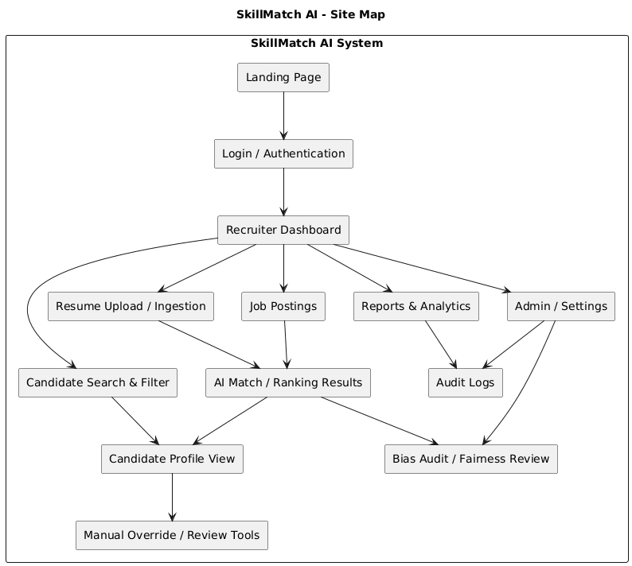

Use Case Diagrams
Ali Benrami
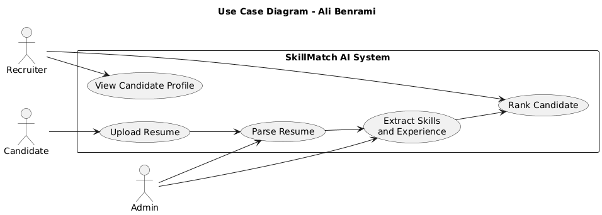

Swara:
Use case diagram
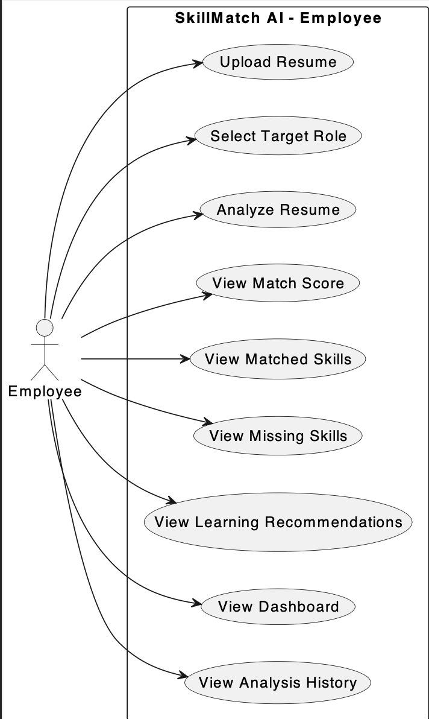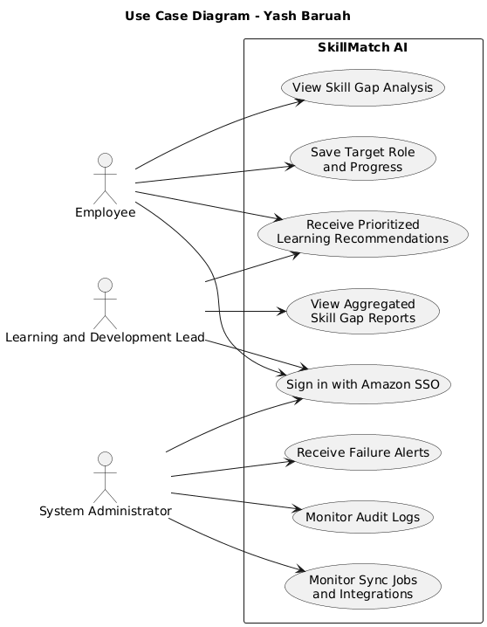

Sequence Diagrams
Ali Benrami
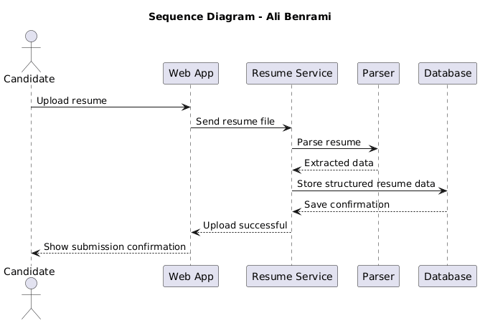
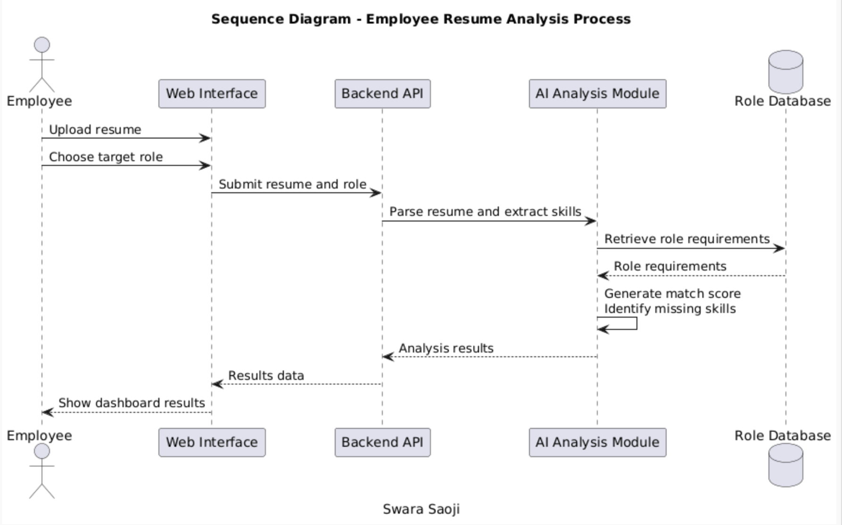

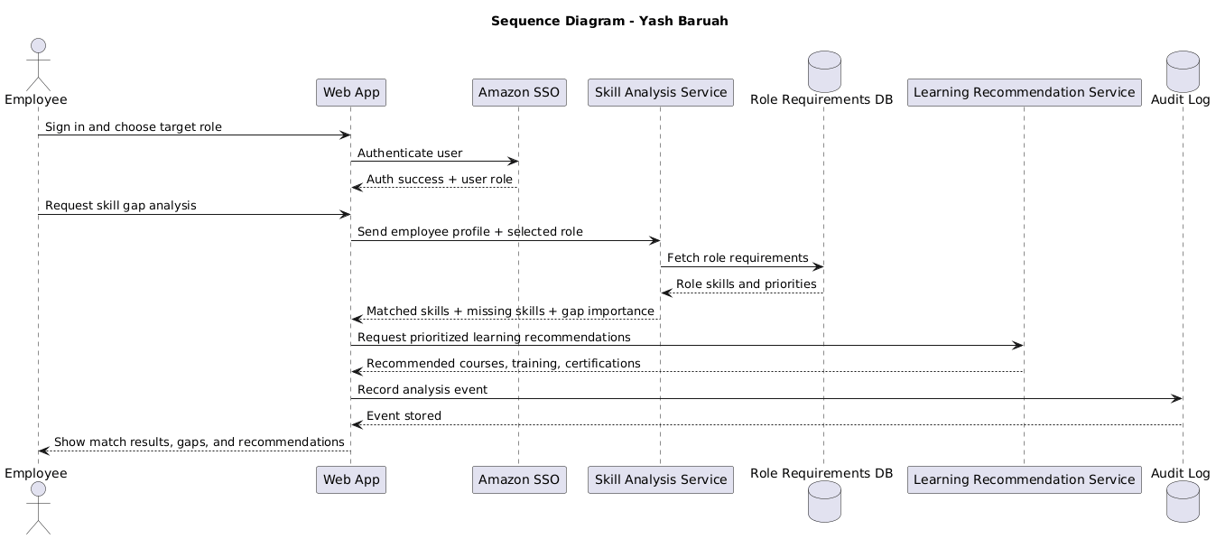

Wire Frames

Swara:

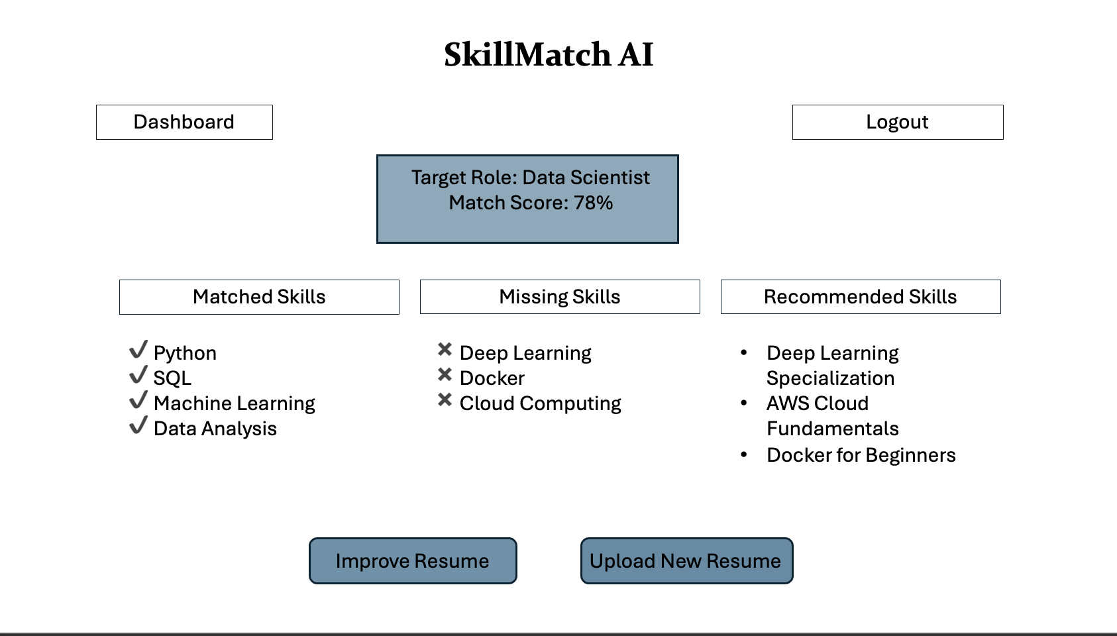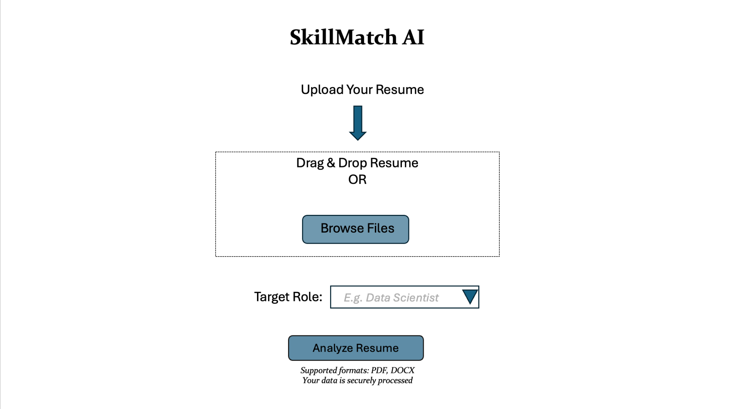
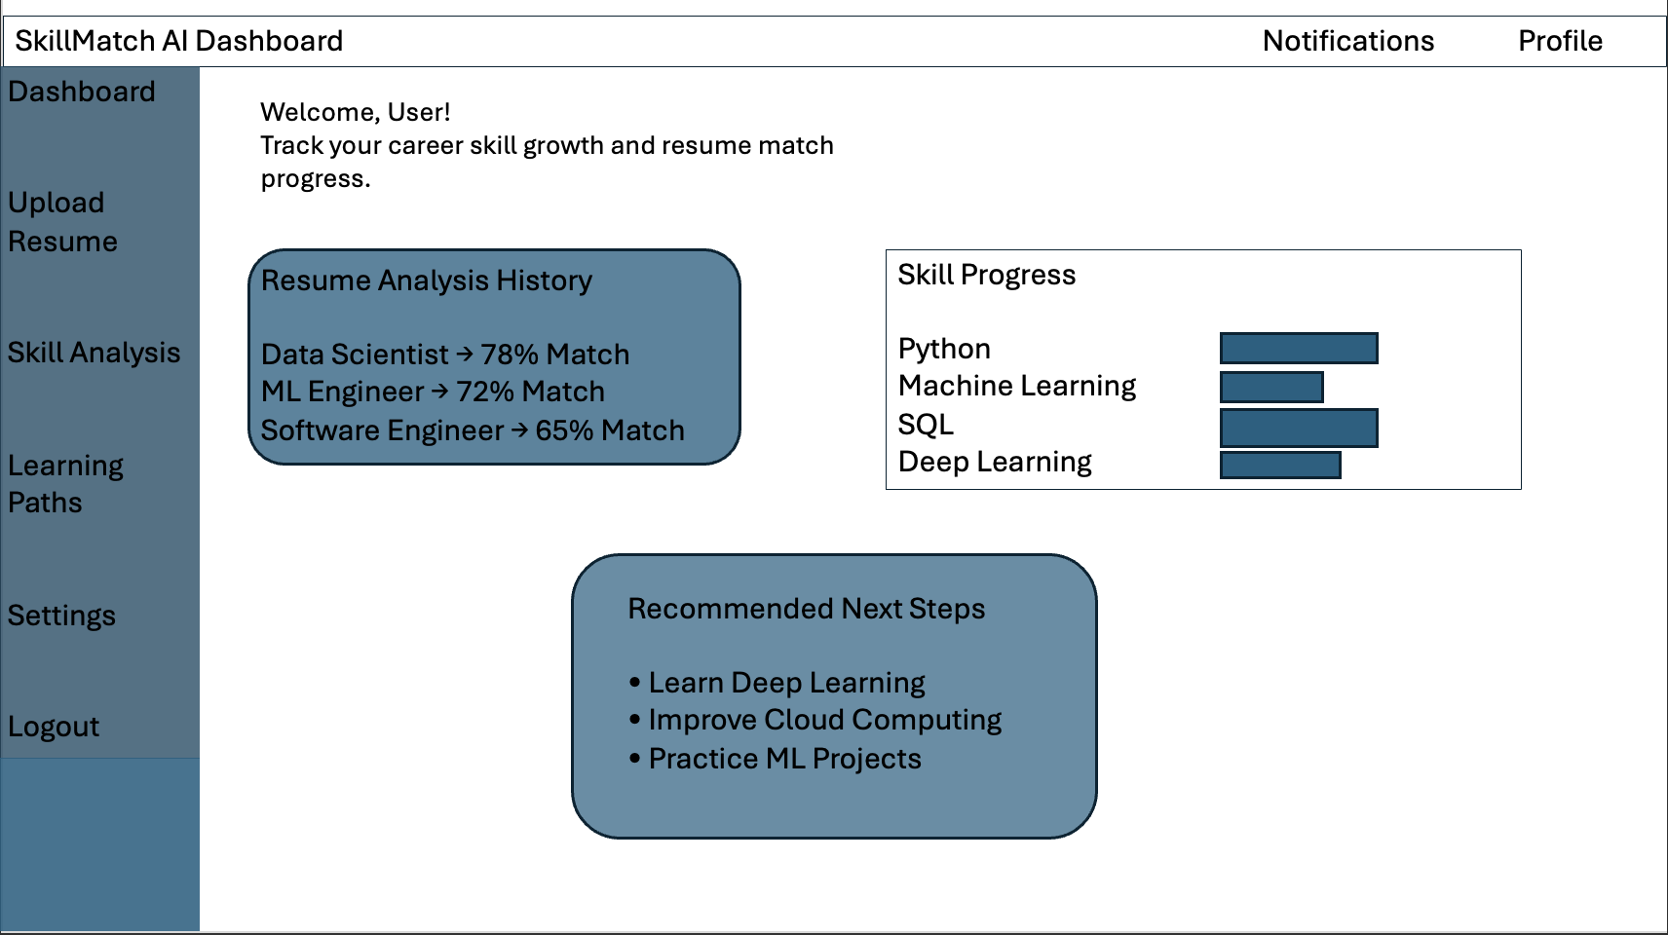
Ali: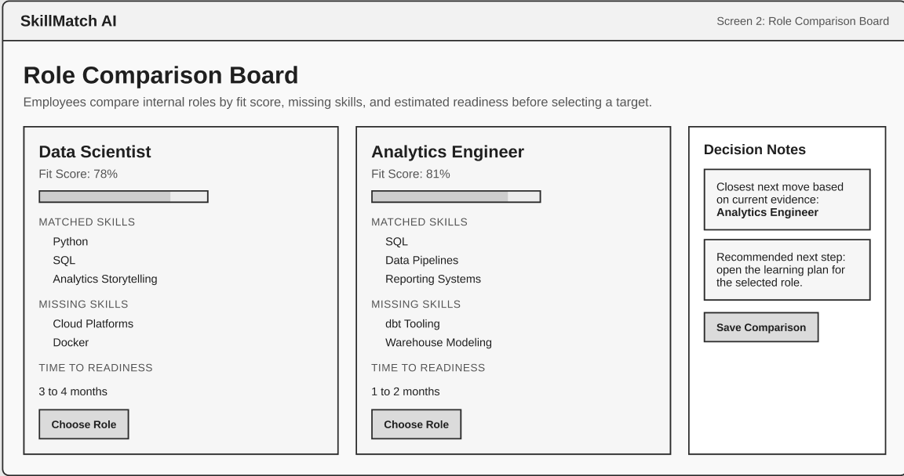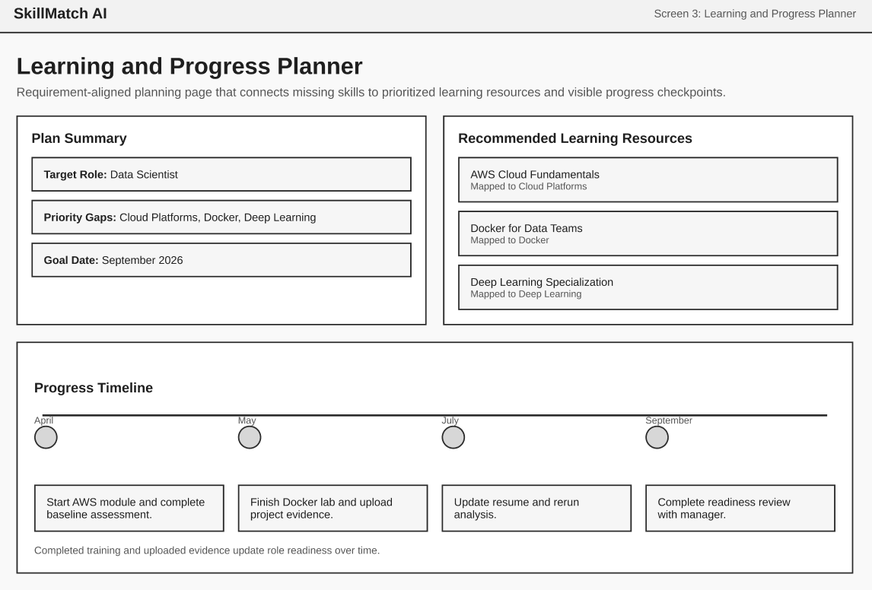
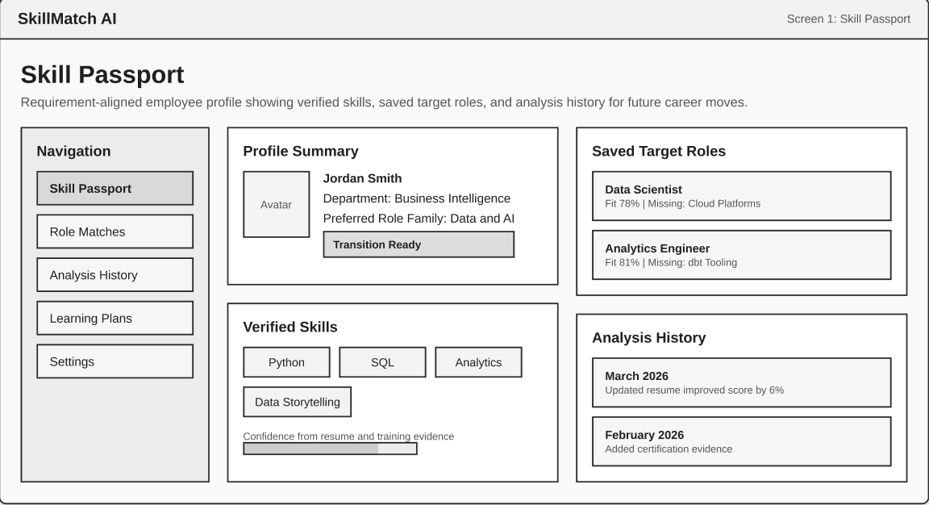

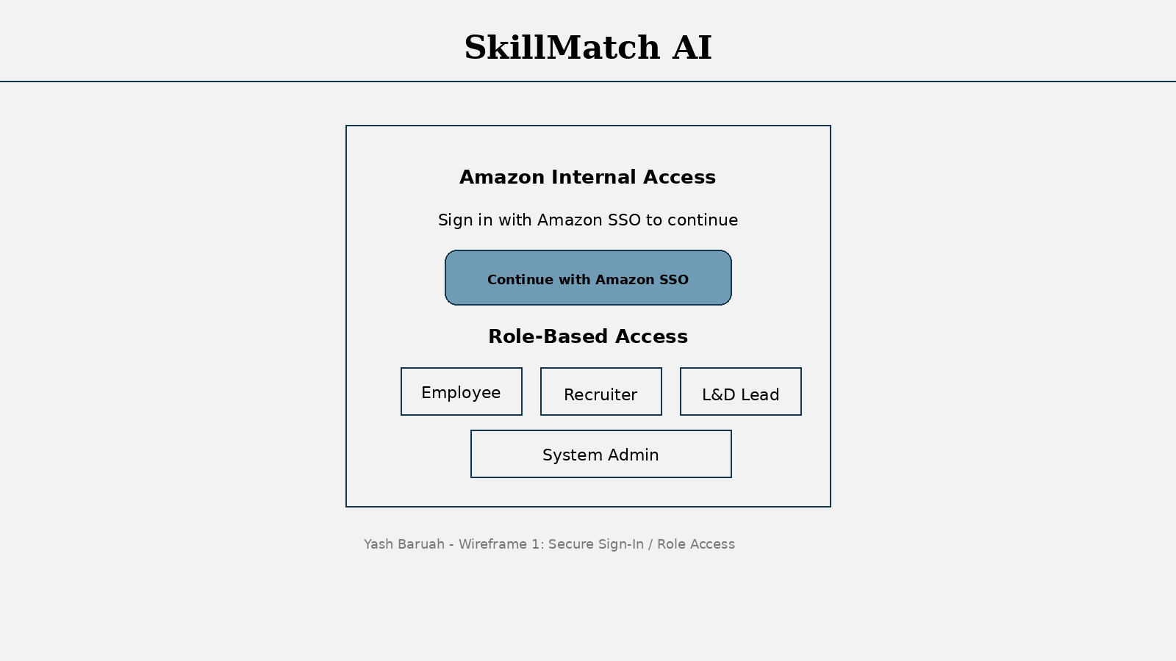
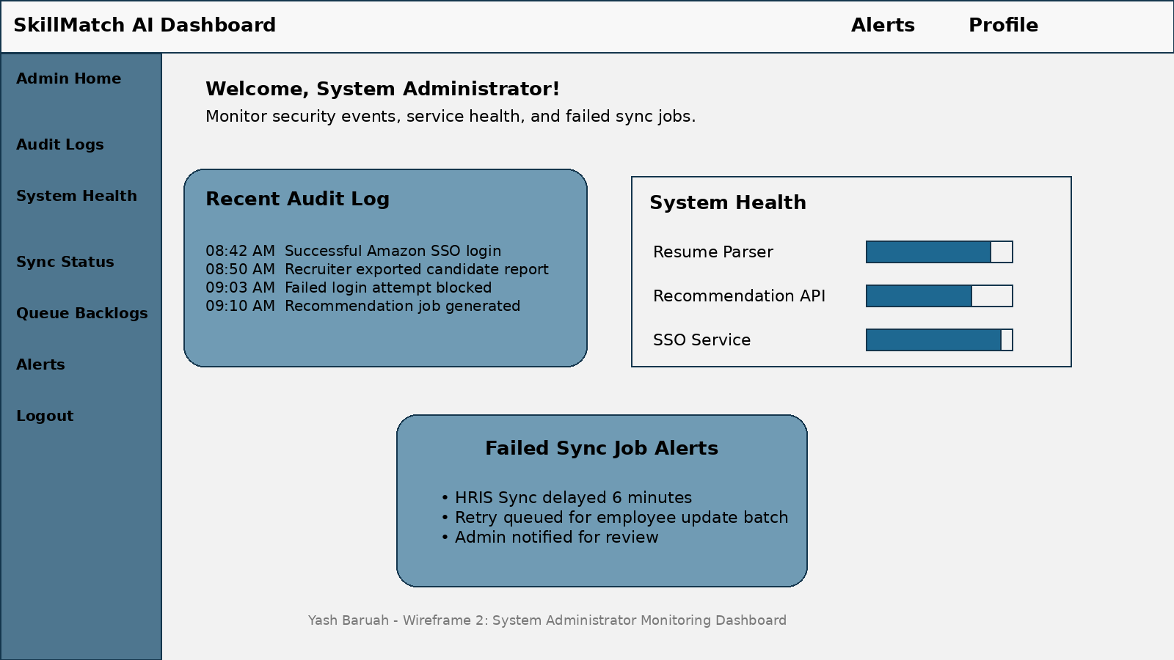

Architecture Design
SkillMatch AI has a multi-user web-based architecture that allows employees and recruiters to use the system through different interfaces that communicate with a common backend. This architecture allows the user interface, system processing, and data storage to operate independently to make the entire system more manageable. Employees can use the SkillMatch AI system to upload their resumes, select their preferred jobs, and view the skill match results, while recruiters can use the SkillMatch AI system to view candidate information, scores, and analytics. Although the user interface provided to employees and recruiters has different functionalities, they communicate with a common set of analysis services.

This architecture follows a layered model with the presentation layer being the user interface that employees and recruiters interact with when they use the SkillMatch AI system to upload their resumes, select their preferred jobs, view their results, view candidate information and scores, and view analytics. In addition, the application layer contains the backend services that process user requests from the user interface, process resumes uploaded by employees, and coordinate the analysis process. There is also an AI analysis component that takes resume information, compares the information with job requirements, and provides scores. Lastly, the data layer stores important information such as resumes, job role requirements, analysis results, and user data in a database.

Separating the user interface, system logic, and database allows the system to be modified easily if more users or features are added in the future. This design provides a reliable platform for analyzing resumes and giving useful insights to both employees and recruiters.

Context Diagram
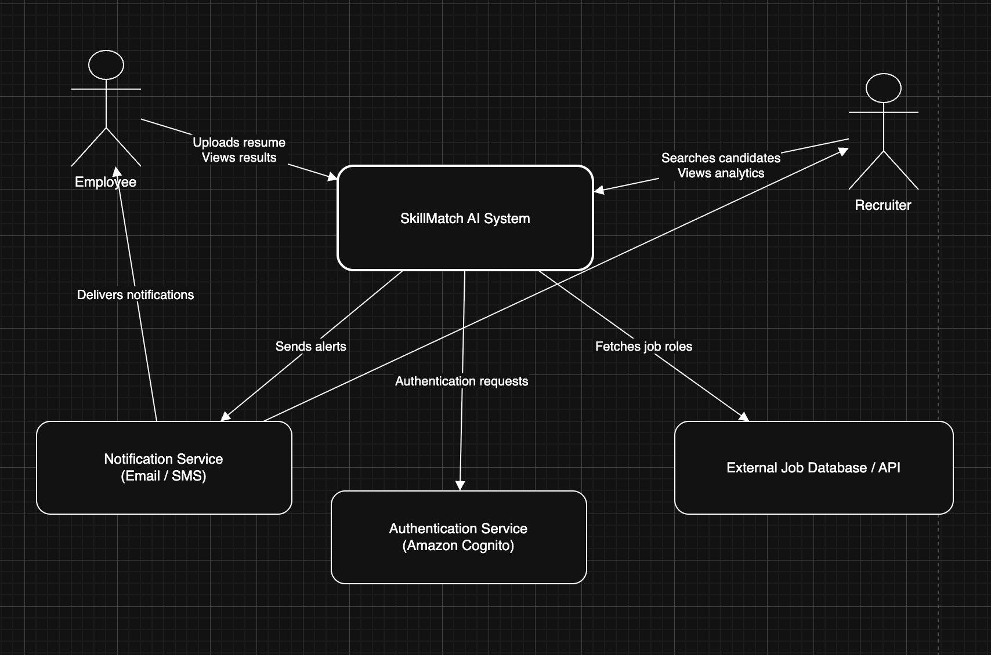

Systems Arch (Logical)

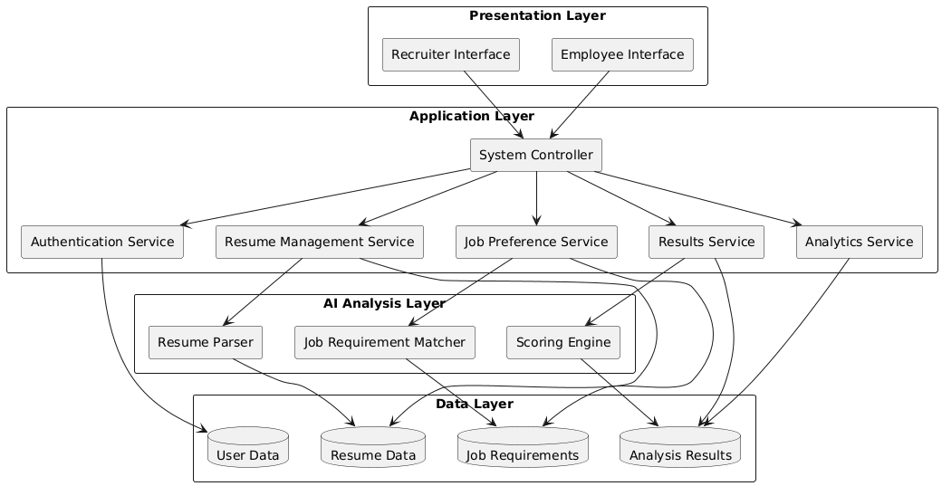

Systems Arch (Physical)

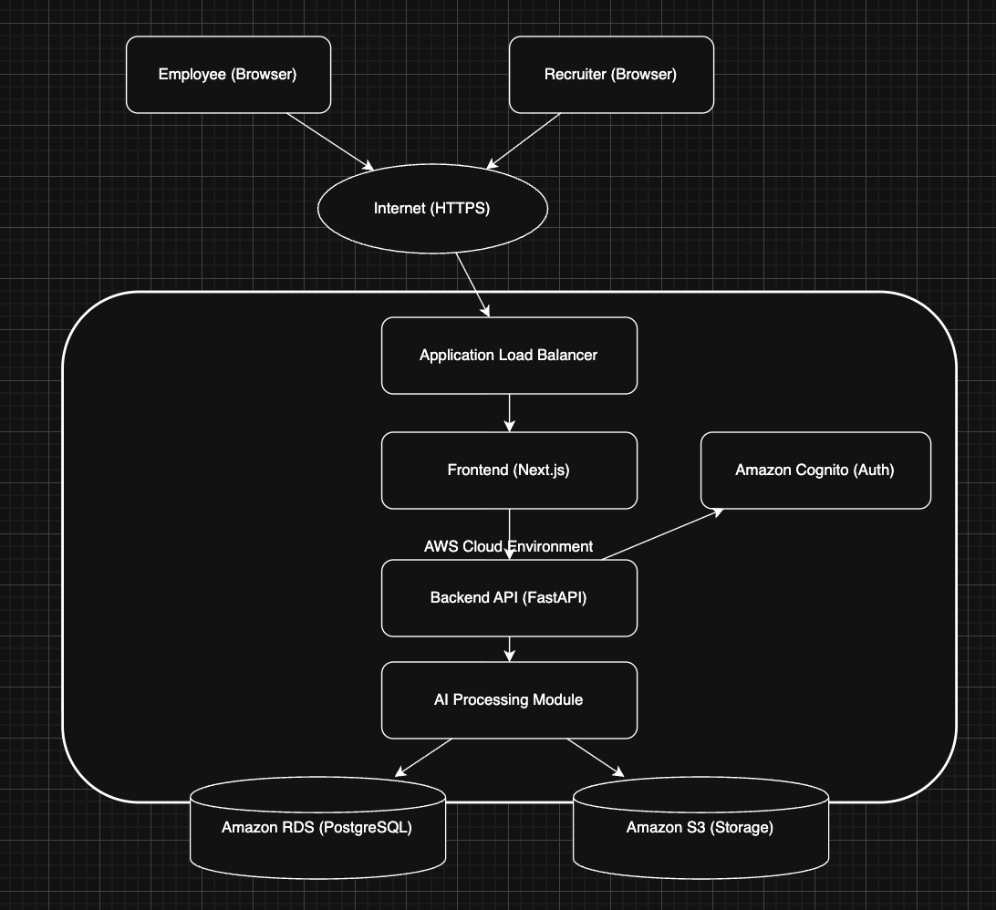

Tech Stack
- Frontend: Next.js
- Styling: Tailwind CSS
- Backend: FastAPI
- Authentication: Amazon Cognito
- Database: Amazon RDS for PostgreSQL
- File Storage: Amazon S3
- ORM: SQLModel
- Containerization: Docker
- Hosting / Deployment: AWS App Runner
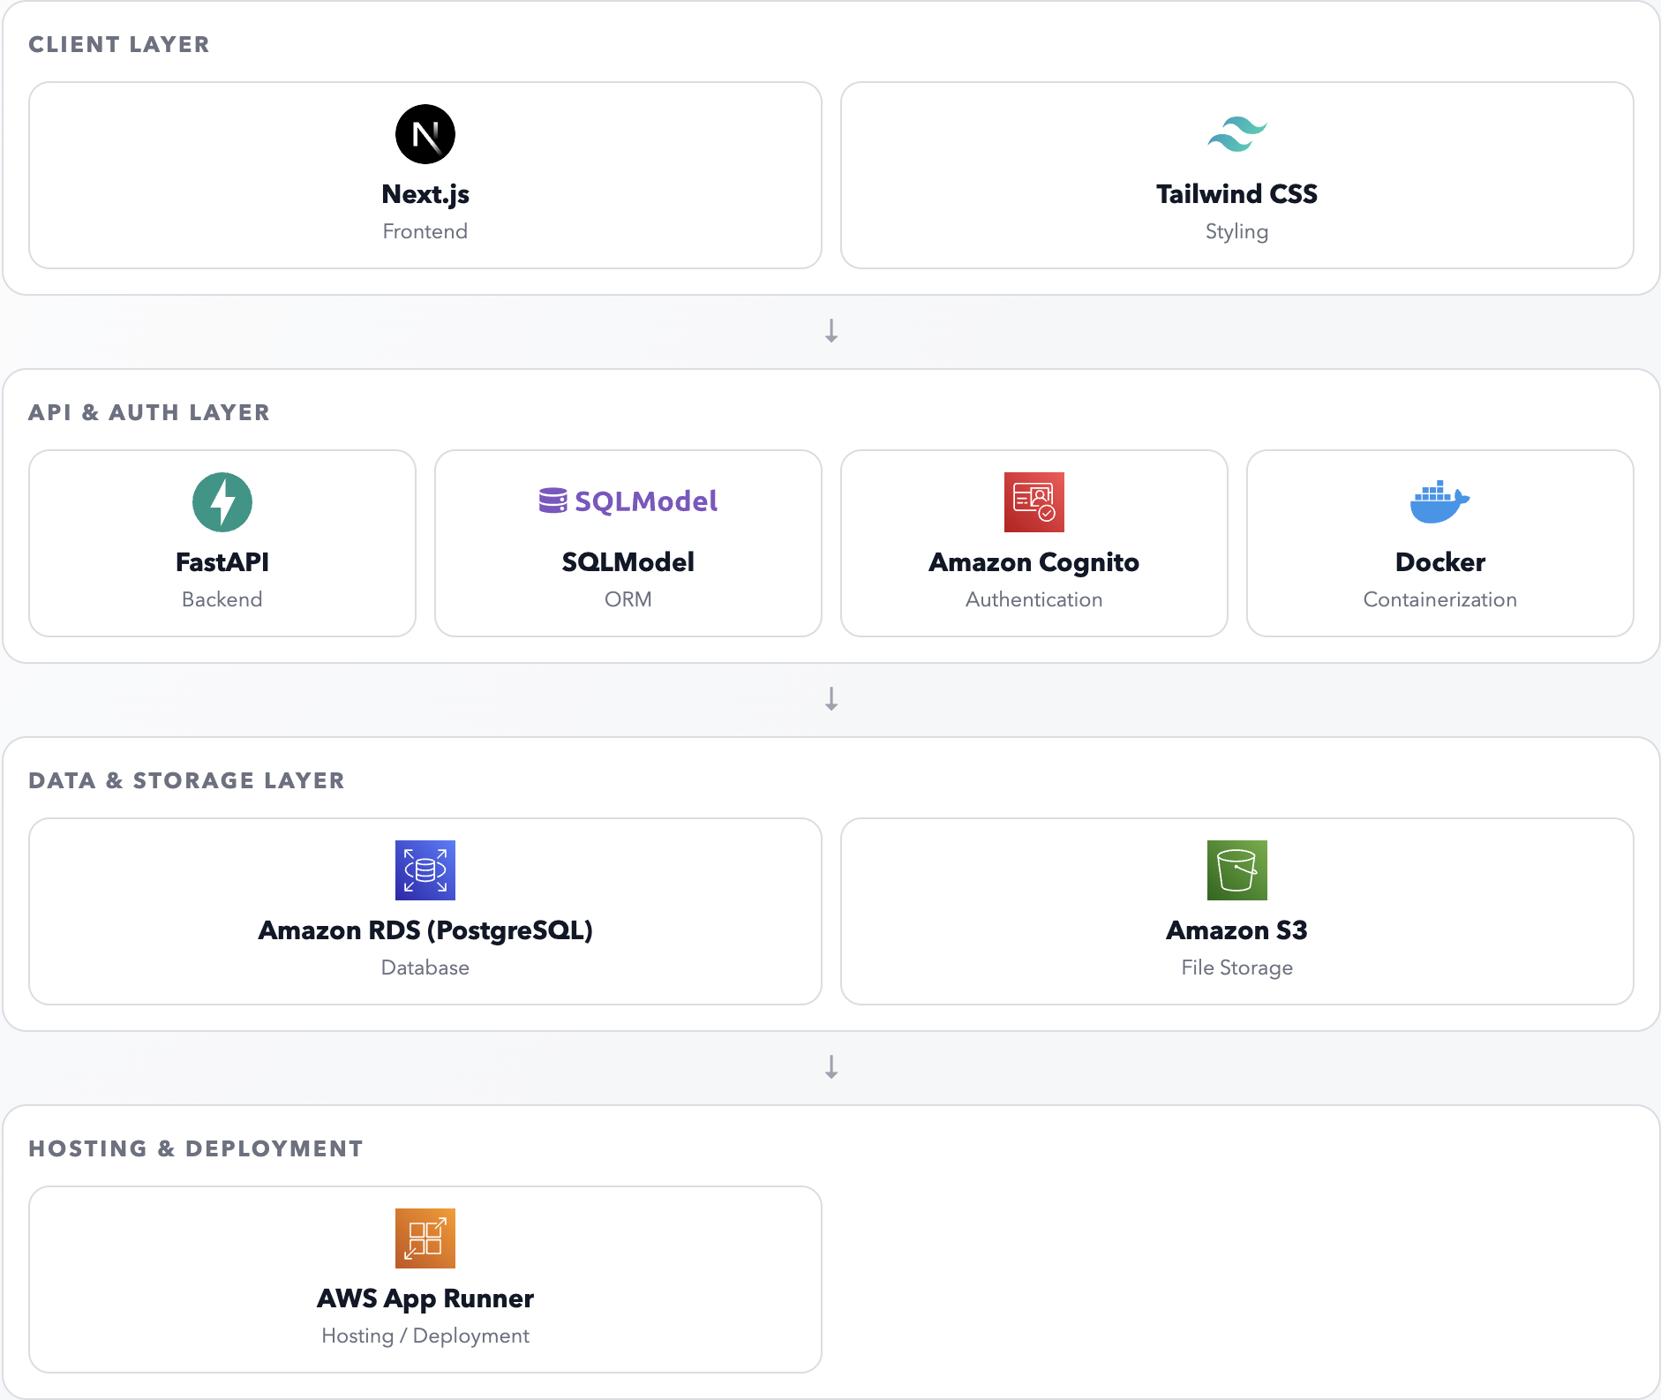

UML Classes
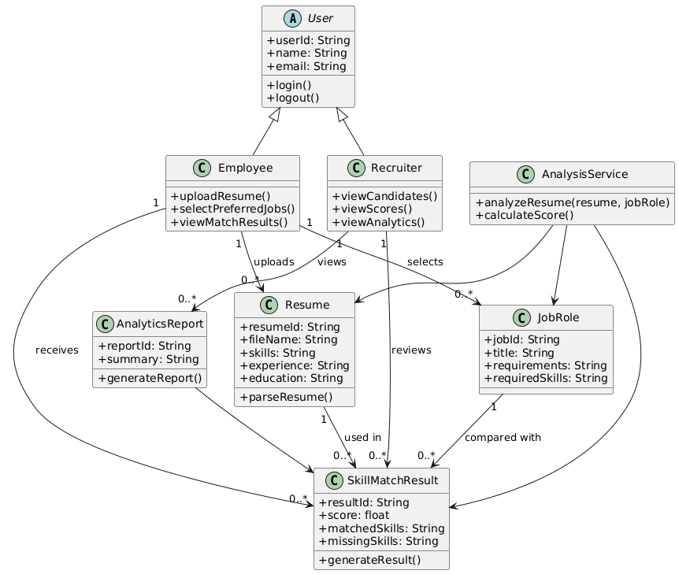

Software Testing
The testing plan for SkillMatch AI will be designed in such a way that the system will be able to meet the requirements that have been identified in the above document and function properly for the identified users and services. It will involve functional testing of the system, which will cover features such as Amazon single sign-on, access control based on roles, audit trails, administrator monitoring, learning recommendations, employee progress, and reporting. It will also involve integration testing of the user interface, services, the AI analysis component, and the database in such a way that no inconsistent results will be obtained. Additionally, non-functional testing will be conducted in order to ensure that the system will be available and reliable for the internal users of Amazon during normal and high-demand hiring seasons.

Testing Technologies and Methodologies
The testing plan for SkillMatch AI is intended to ensure that the system meets the requirements that have been specified throughout this document, as well as ensuring that the system works well for its intended users and services. The testing will involve functional testing, which will include testing the features of the system, including Amazon single sign-on, role-based access control, audit trails, administrator monitoring, learning recommendations, employee progress, and reporting. The testing will also involve integration testing, in which the user interface, the backend service, the AI analysis, and the database will be integrated well without any kind of inconsistency. The testing will also involve non-functional testing, including availability, browser reliability, log protection, and failure handling, in order to ensure that the system is stable enough for Amazon’s internal users.

Test Case and Requirements table
Test Case No. | Test Description | Requirement No. | Requirement Definition | Test Steps
TC 1 | Verify that an employee can upload a resume file. | FR-1 | Employee can upload resume in PDF or DOCX format. | 1. Open upload page  2. Select a PDF or DOCX file  3. Submit file
TC 2 | Verify that an employee can drag and drop a resume into the upload area. | FR-2 | Employee should be able to drag and drop their resume into the upload area. | 1. Open upload page  2. Drag a valid resume file into upload box  3. Release file
TC 3 | Verify that an employee can select a target internal role from the list. | FR-4 | Employee should be able to select a target internal role from the list. | 1. Upload a resume  2. Open role selection menu  3. Select a target role
TC 4 | Verify that the system compares employee skills with the selected role requirements. | FR-5 | Employee’s skills should be compared with the requirements of role. | 1. Upload resume  2. Select target role  3. Start analysis
TC 5 | Verify that the system displays a skill match score. | FR-6 | Employee should be able to view their skill match score for the role. | 1. Upload resume  2. Select role  3. Run analysis
TC 6 | Verify that the system displays missing skills for the selected role. | FR-8 | Employees should be able to see which skills are missing. | 1. Upload resume  2. Select role  3. Run analysis
TC 7 | Verify that the system recommends learning resources for missing skills. | FR-9 | The system should recommend learning resources to help employees develop missing skills. | 1. Upload resume  2. Select role  3. Run analysis  4. View recommendations
TC 8 | Verify that an employee can upload an updated resume and rerun analysis. | FR-10 | Employees should be able to upload an updated resume and rerun the analysis. | 1. Upload first resume  2. Run analysis  3. Upload updated resume  4. Run analysis again
TC 9 | Verify that the interface is simple and easy to use for employees. | NFR-1 | The interface should be simple and easy to use. | 1. Ask test users to complete resume upload and role selection  2. Observe completion without guidance
TC 10 | Verify that the system works on modern web browsers. | NFR-2 | The system should work on modern web browsers. | 1. Open system in Chrome  2. Repeat in Safari  3. Repeat in Edge
Swara:
Test Case No. | Test Description | Requirement No. | Requirement Definition | Test Steps
TC 1 | Verify that Amazon single sign-on is required before a user can access the platform. | FR-1 | The system should require Amazon single sign-on before any internal user can access the platform. | 1. Open the login page  2. Attempt to access the system without signing in  3. Confirm access is blocked  4. Sign in with a valid Amazon account  5. Confirm access is granted
TC 2 | Verify that access permissions are assigned based on user role. | FR-2 | The system should assign access permissions based on user roles such as employee, recruiter, hiring manager, Learning and Development lead, and system administrator. | 1. Sign in as an employee  2. Try to open an admin-only page  3. Confirm access is denied  4. Sign in as an administrator  5. Confirm admin features are available
TC 3 | Verify that the system keeps an audit log of sensitive actions. | FR-3 | The system should keep an audit log of sensitive actions such as logins, failed login attempts, recommendation generation, recruiter overrides, report exports, and administrative updates. | 1. Perform a login  2. Perform a failed login  3. Export a report  4. Open the audit log  5. Confirm the actions are recorded
TC 4 | Verify that system administrators can view system health, sync status, and queue backlogs. | FR-4 | The system should allow system administrators to view system health information, sync status, and queue backlogs from connected services. | 1. Sign in as a system administrator  2. Open the admin dashboard  3. View system health  4. Check sync status  5. Check queue backlog information
TC 5 | Verify that administrators are notified when a connected service or sync job fails. | FR-5 | The system should notify administrators when a connected service, import, or data-sync job fails. | 1. Simulate a connected service failure  2. Trigger a failed sync job  3. Check the admin notification area  4. Confirm a failure alert appears
TC 6 | Verify that safe background jobs are retried after temporary failures. | FR-6 | The system should retry safe background jobs after temporary service failures and prevent partial or inconsistent updates. | 1. Trigger a temporary service failure  2. Start a background job 3. Confirm the job is retried  4. Check that no partial update was saved
TC 7 | Verify that employees can see matched skills, missing skills, and the importance of missing skills. | FR-7 | The system should show employees which skills match a target role, which skills are missing, and how important each missing skill is. | 1. Upload a resume  2. Select a target role  3. Run analysis  4. Confirm matched skills are shown  5. Confirm that missing skills and importance levels are shown
TC 8 | Verify that the system generates prioritized learning recommendations tied to missing skills. | FR-8 | The system should generate prioritized learning recommendations that are directly tied to the employee’s missing skills and selected target role. | 1. Upload a resume  2. Select a target role  3. Run analysis  4. Open recommendations  5. Confirm the recommendations are tied to missing skills and shown in priority order
TC 9 | Verify that employees can save target roles, review previous analyses, and track progress after updates. | FR-9 | The system should allow employees to save target roles, review previous analyses, and track progress after updating skills, training, or certifications. | 1. Upload a resume  2. Select and save a target role  3. Run analysis 4  . Upload updated resume or training data  5. Confirm past analysis and progress tracking are visible
TC 10 | Verify that Learning and Development teams can view aggregated skill-gap reports. | FR-10 | The system should provide Learning and Development teams with aggregated reporting on common skill gaps across departments, employee groups, and role families. | 1. Sign in as a Learning and Development user  2. Open reporting dashboard  3. Generate a report  4. Confirm aggregated skill-gap data is displayed
Yash:

RTM Table
Swara:

 | TC-1 | TC-2 | TC-3 | TC-4 | TC-5 | TC-6 | TC-7 | TC-8 | TC-9 | TC-10
FR-1 | X
FR-2 |  | X
FR-4 |  |  | X
FR-5 |  |  |  | X
FR-6 |  |  |  |  | X
FR-8 |  |  |  |  |  | X
FR-9 |  |  |  |  |  |  | X
FR-10 |  |  |  |  |  |  |  | X
NFR-1 |  |  |  |  |  |  |  |  | X
NFR-2 |  |  |  |  |  |  |  |  |  | X

Yash:

 | TC-1 | TC-2 | TC-3 | TC-4 | TC-5 | TC-6 | TC-7 | TC-8 | TC-9 | TC-10
FR-1 | X
FR-2 |  | X
FR-3 |  |  | X
FR-4 |  |  |  | X
FR-5 |  |  |  |  | X
FR-6 |  |  |  |  |  | X
FR-7 |  |  |  |  |  |  | X
FR-8 |  |  |  |  |  |  |  | X
FR-9 |  |  |  |  |  |  |  |  | X
FR-10 |  |  |  |  |  |  |  |  |  | X
NFR-1 |  |  |  | X |  |  |  |  |  | X
NFR-2 |  |  | X
NFR-3 |  | X |  |  |  |  |  |  |  | X
NFR-4 |  |  |  |  | X | X

Software Evolution
SkillMatch AI is intended to become more advanced over time as the needs and demands for hiring and other aspects of internal roles and skill development evolve. As the software is built with multiple layers and includes an interface, application, AI analysis, and data storage sections, this would make it easier to implement further features into the system. The evolution of this software could involve additional aspects, such as additional internal role types, more detailed resume analysis, more detailed reports for the Learning and Development team, and more recommendations based on evolving skill needs across departments. This would allow the software to remain relevant as the hiring and training needs evolve with Amazon.
To ensure the maintenance of the system for an extended period of time, SkillMatch AI must also receive upgrades in the form of regular security patches, model upgrades, browser upgrades, and version upgrades based on system performance and user feedback. Since the project already emphasizes the importance of role-based access control, audit logging, backup and recovery, failure isolation, and updates with minimum interruption, the evolutionary development process must ensure the stability of the system while also enhancing the system over time. All upgrades must continue to be recorded in the SED so that the system development process can be tracked over time.

Glossary of Terms
SkillMatch AI: It is a web-based tool that uses artificial intelligence to analyze resumes and measure the extent to which a person’s skills align with a given job role.
Resume Parsing: It refers to the process of automatically analyzing a resume to obtain information that can be used to measure a person’s skills.
Match Score: It refers to the extent to which a person’s skills align with a given job role.
Skill Gap: It refers to the skills required to perform a job role that may not be indicated on a resume. AI Analysis Module: It refers to the part of the system that performs the analysis on the resume to obtain information that can be used to measure a person’s skills. Dashboard: It refers to the user interface that displays information to the user.
Requirements of a Role: It refers to the skills required to perform a given job role. Learning Recommendations: It refers to the suggestions given to the user to improve their skills. Backend API: It refers to the backend part of the system that processes user requests.
Database: A system for storing resumes, job roles, analysis results, user information, and system logs.
User Interface (UI): A component of the system where users interact with the system, such as forms, dashboards, and visual displays.
Role-Based Access Control (RBAC): This is a security feature that restricts access to the system based on the user’s role and permission levels.
Audit Log: This refers to a log of events that occur within the system, such as user login, modification of data, and actions performed by administrators.
System Administrator: This refers to a user who oversees the entire system, including users, the performance of the system, and security features.
Learning and Development (L&D): This refers to a department within an organization that has the responsibility of providing training to the employees of the organization.
System Scalability: This refers to the ability of a system to accommodate more users without affecting the performance of the system.
Single Sign-On (SSO): This refers to a security feature that allows users to access multiple systems without the need to re-enter their credentials.

